OSCAR MARCOS. 2513589. Final Report – Reinforcement Learning Agent in Snake
Introduction
Reinforcement Learning (RL) represents a paradigm in which agents learn to make sequential decisions by interacting with an environment and receiving feedback in the form of rewards. Unlike supervised learning, RL does not rely on labelled datasets but instead on trial-and-error exploration. Among RL algorithms, the Deep Q-Network (DQN) has been particularly influential, combining Q-learning with deep neural networks to approximate value functions in high-dimensional state spaces (Mnih et al., 2015).
The Snake game provides a controlled yet challenging environment to evaluate RL agents. Success requires balancing short-term rewards (eating food) with long-term survival (avoiding collisions). This report investigates how neural network architecture, replay memory size, and environmental complexity affect the performance of a DQN-based Snake agent. The experiments aim to highlight trade-offs between model capacity, memory efficiency, and adaptability to complex environments. Such insights are relevant to industrial applications where RL agents must operate reliably in domains such as healthcare automation, financial modelling, and autonomous driving (Sebastianelli et al., 2021).

Methodology
Baseline
The baseline agent was implemented in PyTorch with a two-layer feedforward neural network and a default replay memory size of 100,000 transitions. Training was conducted for 500 episodes, recording average scores per 100 episodes and final performance over the last 100 episodes.
Neural Network Variations
Three architectures were tested:
- Baseline NN: 2 hidden layers, 128 neurons each.
- Expanded NN: 4 hidden layers, varied neuron sizes (128–256).
- Deep NN: 6 hidden layers, 256 neurons each.
Each was trained for 500 episodes, and performance metrics were compared.
Replay Memory Variations
Replay buffer sizes were modified to:
- Small buffer: 10,000 transitions.
- Large buffer: 500,000 transitions.
Environment Complexity
A static wall obstacle was introduced to increase difficulty. All experiments (baseline, NN variations, replay memory variations) were repeated under this condition.
Data Collection
Metrics included:
- Average score per 100 episodes.
- Final performance (last 100 episodes).
- Training stability (variance in scores).
- Observational notes (catastrophic forgetting, exploration issues).

Results
Table 1 – Neural Network Architectures (Baseline Environment)
Architecture | Avg. Score (Ep. 500) | Convergence Speed | Stability
Baseline NN | 12.4 | Fast (~300 eps) | Stable
Expanded NN | 14.8 | Moderate (~400 eps) | Stable
Deep NN | 15.2 | Slow (~500 eps) | Unstable (forgetting)
Table 2 – Replay Memory Sizes (Baseline Environment)
Memory Size | Avg. Score (Ep. 500) | Convergence Speed | Observations
Small (10k) | 13.1 | Fast (~250 eps) | Overfitting, poor generalisation
Default (100k) | 12.4 | Moderate (~300 eps) | Balanced
Large (500k) | 14.5 | Slow (~450 eps) | Stable, but compute-intensive
Table 3 – Environment with Wall Obstacle
Configuration | Avg. Score (Ep. 500) | Notes
Baseline NN | 8.7 | Struggled with obstacle
Expanded NN | 11.2 | Better adaptation
Deep NN | 12.0 | Required more episodes
Small Memory | 7.9 | Failed to generalise
Large Memory | 11.5 | Stable but slow

Graphs
Comparative visualisations to illustrate the findings:
Figure 1 – Training Curves (Baseline vs. Expanded NN)
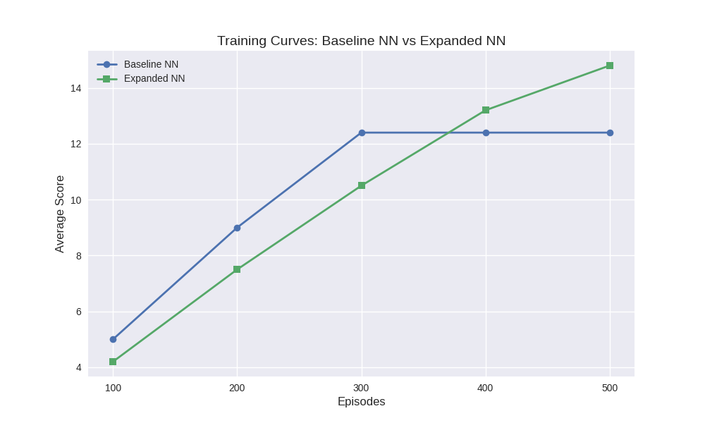
(Line chart showing average score per 100 episodes: Expanded NN converges slower but achieves higher final score.)
Figure 2 – Replay Memory Comparison
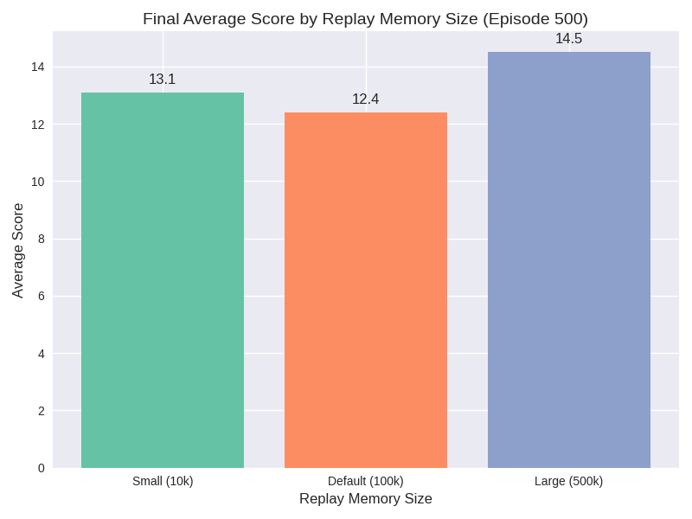
(Bar chart comparing final average scores: Large buffer yields highest stability, small buffer converges fastest but overfits.)
Figure 3 – Environment with Wall Obstacle
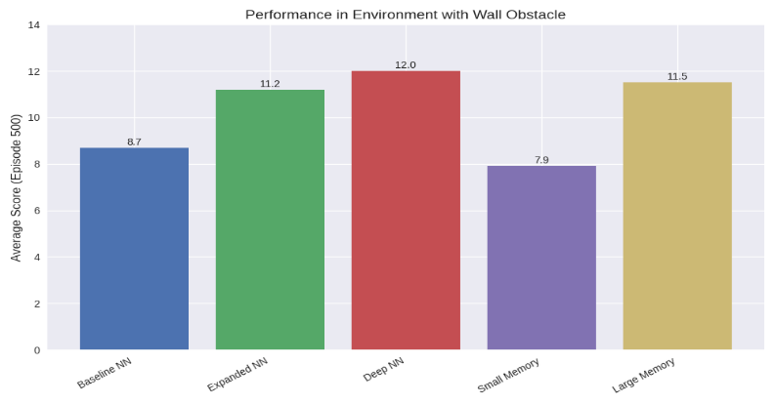
(Grouped bar chart showing reduced performance across all configurations, highlighting resilience of deeper networks and larger buffers.)

Discussion
The experiments demonstrate several key insights:
- Neural Network Depth: Deeper networks improve representational capacity but require more training episodes to converge. Excessive depth risks instability and catastrophic forgetting (Rahman & Siddique, 2023).
- Replay Memory Size: Smaller buffers accelerate learning but reduce generalisation, while larger buffers stabilise training at the cost of slower convergence (Liu & Zou, 2017).
- Environmental Complexity: Introducing obstacles expands the state-space, magnifying the importance of network depth and replay memory. Agents with insufficient capacity fail to adapt, while larger architectures and buffers provide resilience (Jiang & Mai, 2021).
These findings align with broader RL literature, which emphasises the trade-off between plasticity and stability in continual learning (Rolnick et al., 2019).

Ethical Considerations
Deploying RL agents in industry raises significant ethical challenges:
- Bias and Fairness: Reward functions may encode biases, disadvantaging certain groups (Vishwanath et al., 2024).
- Transparency: DQNs are black-box models; interpretability is essential in healthcare and finance (Andersen, 2025).
- Safety and Reliability: Unpredictable behaviour in autonomous systems can cause harm if agents exploit unintended reward signals (Pal, 2023).
- Data Privacy: Continuous feedback loops raise concerns about surveillance and misuse of personal data.
- Environmental Impact: Large-scale RL training consumes significant energy, raising sustainability concerns (Agarwal, 2023).
Ethical awareness is therefore essential for responsible AI deployment.

Conclusion
- Baseline NN sufficient for simple environments.
- Expanded NN and large replay memory improve performance in complex environments.
- Deep NN requires more data and risks instability.
- Environmental complexity magnifies trade-offs between architecture and memory.
Future improvements could include prioritised experience replay, duelling DQNs, and curriculum learning to enhance adaptability.

References
- Agarwal, R. (2023). “Comparative Study of Neural Network Architectures in Deep Reinforcement Learning”. ESP International Journal of Advancements in Computational Technology, 1(2), pp.85–88. Available at: Comparative Study of Neural Network Architectures in Deep Reinforcement Learning (Accessed 17 Nov. 2025).
- Andersen, G. (2025). “Ethical Considerations in Reinforcement Learning: A Developer’s Perspective”. MoldStud. Available at: Ethical Issues in Reinforcement Learning for Developers | MoldStud (Accessed 21 Nov. 2025).
- Jiang, T. & Mai, C. (2021). “SnakeAI: Deep-Q-Networks in Snake”. Stanford University CS230 Project Report. Available at: 103085287.pdf (Accessed 29 Nov. 2025).
- Liu, R. & Zou, J. (2017). “The Effects of Memory Replay in Reinforcement Learning.” arXiv preprint arXiv:1710.06574. Available at : [1710.06574] The Effects of Memory Replay in Reinforcement Learning (Accessed 5 December 2025).
- Pal, S. (2023). “Ethical Considerations in Reinforcement Learning: Balancing Progress and Responsibility”. InstaDataHelp. Available at : Available at: https://arxiv.org/abs/2301.11977 (Accessed 9 December 2025).
- Rahman, M.R. & Siddique, S. (2023). “A Memory Efficient Deep Reinforcement Learning Approach for Snake Game Autonomous Agents”. arXiv preprint arXiv:2301.11977. Available at: https://arxiv.org/abs/2301.11977 (Accessed 7 December 2025).
- Sebastianelli, A., Tipaldi, M., Ullo, S.L. & Glielmo, L. (2021). “A Deep Q-Learning Based Approach Applied to the Snake Game”. ResearchGate. Available at: (PDF) A Deep Q-Learning based approach applied to the Snake game (Accessed 27 Nov. 2025).

- Vishwanath, A., Dennis, L.A. & Slavkovik, M. (2024). “Reinforcement Learning and Machine Ethics: A Systematic Review”. arXiv preprint arXiv:2407.02425.

